Bug Report
Department 3 – HisabDo Website Enhancement | SQA Team
Website: hisabdo.app | Consolidated Bug List (as of Aug 24, 2026)

1. Overview
This report consolidates all bugs identified during SQA testing of the HisabDo website, including the initial testing cycle and the retest performed after MERN's first round of fixes. All items below require developer attention before final sign-off.

2. Bug List
ID | Area | Description | Severity | Status
ISS-01 | Broken Link | GitHub link in Mian Usman Khalid's founder profile section returns 404 Not Found. | High | Open
ISS-02 | Performance | Total page payload ~4,848 KiB causes LCP of 21.0s on mobile/slow network (threshold: 2.5s). | High | Open
ISS-03 | Performance/Layout | Cumulative Layout Shift (CLS) 0.874 due to images missing width/height attributes. | High | Open
ISS-04 | Performance | 151 KiB unused JavaScript and 18 KiB unused CSS shipped unnecessarily. | Medium | Open
ISS-05 | Responsiveness | Homepage content shows uneven spacing/overflow on mobile screens. | Medium | Open
ISS-06 | Performance | One long main-thread task flagged (low impact, TBT already good). | Low | Open
ISS-07 | Form Validation | Careers/Internship form accepts invalid email format with no error shown. | High | Needs Clarification
ISS-08 | Form Validation | Phone field accepts letters/text instead of numeric-only input. | High | Needs Clarification
ISS-09 | Form Validation | File upload field accepts invalid file types without restriction. | Medium | Needs Clarification
ISS-10 | Code Quality / Critical | Unresolved Git merge conflict markers found in app/globals.css (<<<<<<< HEAD ... ======= ... >>>>>>>), leaving the stylesheet invalid. | Critical | Open (New)

3. Notes
- ISS-07/08/09: The Careers/Internship 'Apply' button links to an external Google Form (forms.gle), not a form built into the website's own code. Clarification is needed on whether this is in MERN's scope or a separate, external tool.
- ISS-10 is a new, critical issue discovered only after MERN's fix attempt — see Regression Report.

Evidence — Screenshots

ISS-01: GitHub Link Still Broken
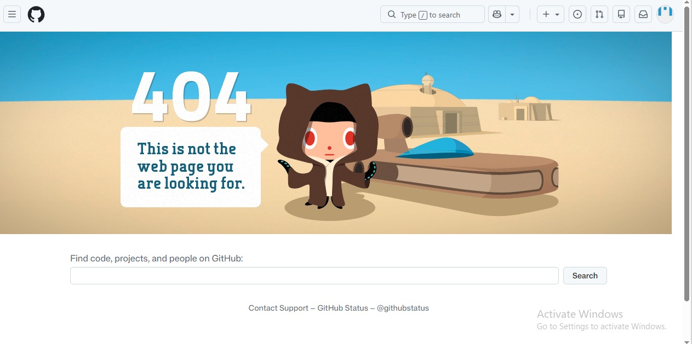
Clicking the GitHub link in the founder profile section leads to a GitHub 404 page.

ISS-07 / ISS-08 / ISS-09: Form Accepts Invalid Data
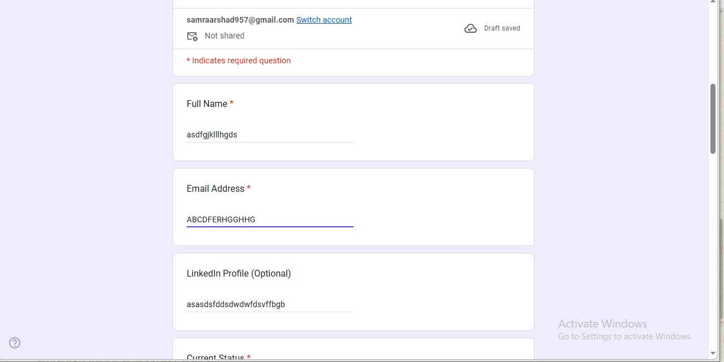
Random/invalid text entered in Full Name, Email Address, and LinkedIn Profile fields — no validation error shown.
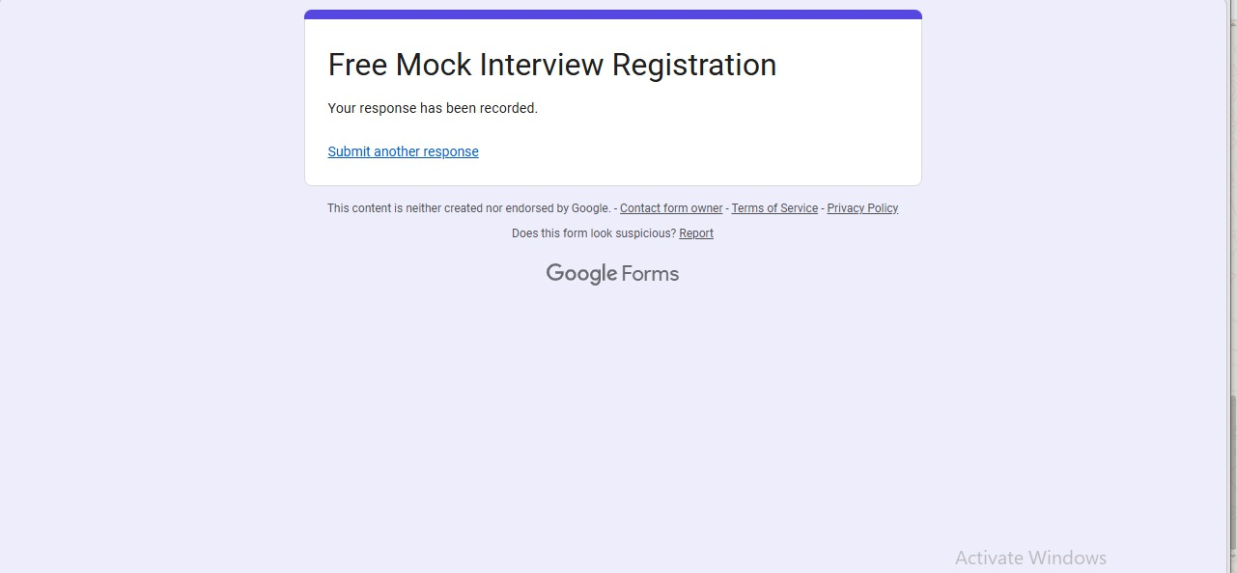
The form accepted the invalid data above and confirmed successful submission — proving no validation is in place.

ISS-05: Mobile Layout Overflow
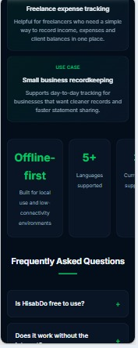
On mobile, the stat cards row overflows the screen width — the third card ('Currencies supported') is cut off and only partially visible.
Prepared by: Samra Arshad (SQA Team Lead)
Date: ______________________

